 |  | 2023
  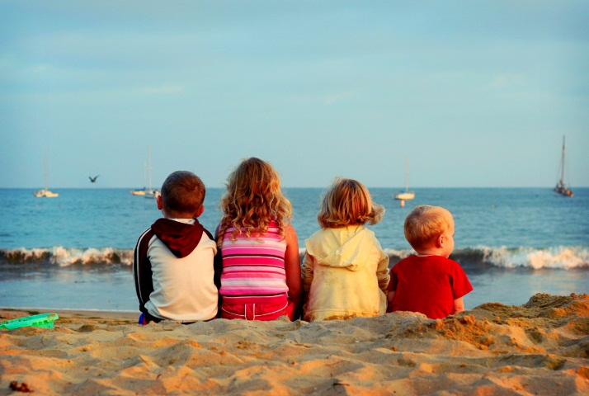
  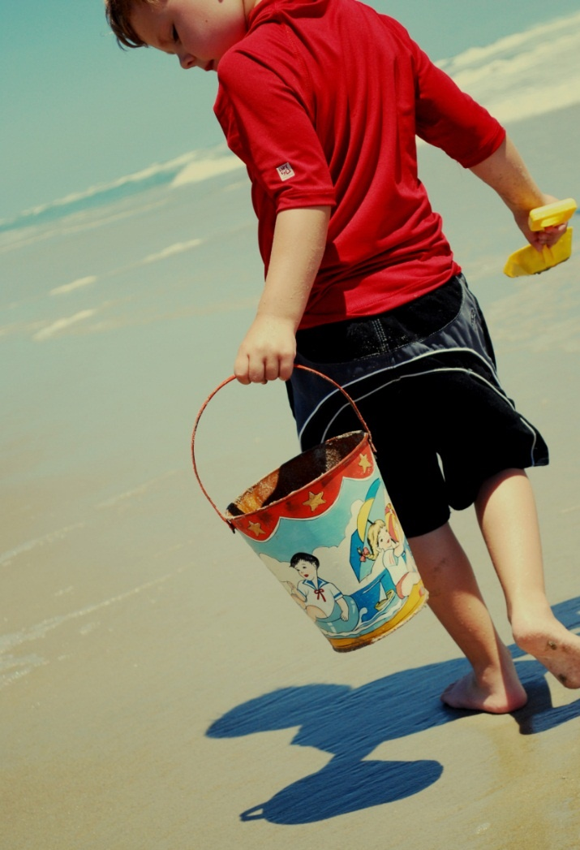
  January |  | May |  | September
    S | M | T | W | T | F | S
    1 | 2 | 3 | 4 | 5 | 6 | 7
    8 | 9 | 10 | 11 | 12 | 13 | 14
    15 | 16 | 17 | 18 | 19 | 20 | 21
    22 | 23 | 24 | 25 | 26 | 27 | 28
    29 | 30 | 31
    S | M | T | W | T | F | S
     | 1 | 2 | 3 | 4 | 5 | 6
    7 | 8 | 9 | 10 | 11 | 12 | 13
    14 | 15 | 16 | 17 | 18 | 19 | 20
    21 | 22 | 23 | 24 | 25 | 26 | 27
    28 | 29 | 30 | 31
    S | M | T | W | T | F | S
     |  |  |  |  | 1 | 2
    3 | 4 | 5 | 6 | 7 | 8 | 9
    10 | 11 | 12 | 13 | 14 | 15 | 16
    17 | 18 | 19 | 20 | 21 | 22 | 23
    24 | 25 | 26 | 27 | 28 | 29 | 30
  February |  | June |  | October
    S | M | T | W | T | F | S
     |  |  | 1 | 2 | 3 | 4
    5 | 6 | 7 | 8 | 9 | 10 | 11
    12 | 13 | 14 | 15 | 16 | 17 | 18
    19 | 20 | 21 | 22 | 23 | 24 | 25
    26 | 27 | 28
    S | M | T | W | T | F | S
     |  |  |  | 1 | 2 | 3
    4 | 5 | 6 | 7 | 8 | 9 | 10
    11 | 12 | 13 | 14 | 15 | 16 | 17
    18 | 19 | 20 | 21 | 22 | 23 | 24
    25 | 26 | 27 | 28 | 29 | 30
    S | M | T | W | T | F | S
    1 | 2 | 3 | 4 | 5 | 6 | 7
    8 | 9 | 10 | 11 | 12 | 13 | 14
    15 | 16 | 17 | 18 | 19 | 20 | 21
    22 | 23 | 24 | 25 | 26 | 27 | 28
    29 | 30 | 31
  March |  | July |  | November
    S | M | T | W | T | F | S
     |  |  | 1 | 2 | 3 | 4
    5 | 6 | 7 | 8 | 9 | 10 | 11
    12 | 13 | 14 | 15 | 16 | 17 | 18
    19 | 20 | 21 | 22 | 23 | 24 | 25
    26 | 27 | 28 | 29 | 30 | 31
    S | M | T | W | T | F | S
     |  |  |  |  |  | 1
    2 | 3 | 4 | 5 | 6 | 7 | 8
    9 | 10 | 11 | 12 | 13 | 14 | 15
    16 | 17 | 18 | 19 | 20 | 21 | 22
    23 | 24 | 25 | 26 | 27 | 28 | 29
    30 | 31
    S | M | T | W | T | F | S
     |  |  | 1 | 2 | 3 | 4
    5 | 6 | 7 | 8 | 9 | 10 | 11
    12 | 13 | 14 | 15 | 16 | 17 | 18
    19 | 20 | 21 | 22 | 23 | 24 | 25
    26 | 27 | 28 | 29 | 30
  April |  | August |  | December
    S | M | T | W | T | F | S
     |  |  |  |  |  | 1
    2 | 3 | 4 | 5 | 6 | 7 | 8
    9 | 10 | 11 | 12 | 13 | 14 | 15
    16 | 17 | 18 | 19 | 20 | 21 | 22
    23 | 24 | 25 | 26 | 27 | 28 | 29
    30
    S | M | T | W | T | F | S
     |  | 1 | 2 | 3 | 4 | 5
    6 | 7 | 8 | 9 | 10 | 11 | 12
    13 | 14 | 15 | 16 | 17 | 18 | 19
    20 | 21 | 22 | 23 | 24 | 25 | 26
    27 | 28 | 29 | 30 | 31
    S | M | T | W | T | F | S
     |  |  |  |  | 1 | 2
    3 | 4 | 5 | 6 | 7 | 8 | 9
    10 | 11 | 12 | 13 | 14 | 15 | 16
    17 | 18 | 19 | 20 | 21 | 22 | 23
    24 | 25 | 26 | 27 | 28 | 29 | 30
    31

